# Lab-5 WAP to study Using arithmetic operators in Prolog.

Procedure:- Write programs to-

* Accept name of the student, rollno, his subject name ,maximum marks and obtained marks in the subject. (Take marks of atleast 6 subjects ) . Compute the percentage of a student. Display his result with other information. Use variables, arithmetic operators, I/O predicates appropriately.

**Code:**

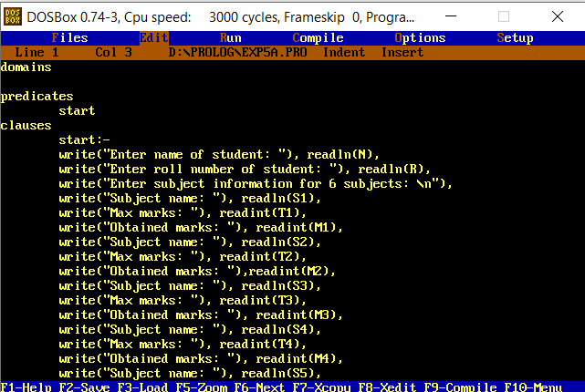

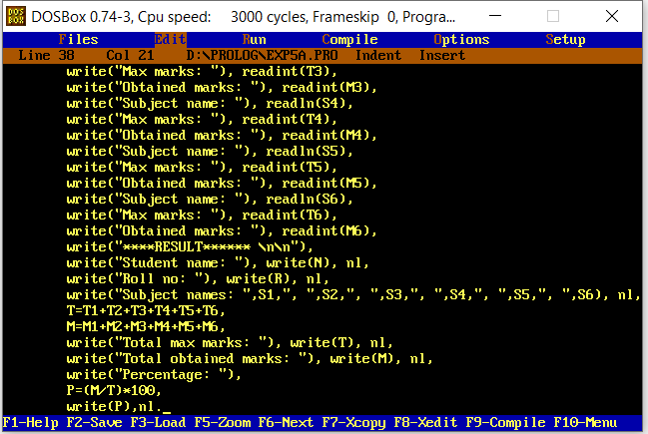

**Output:**

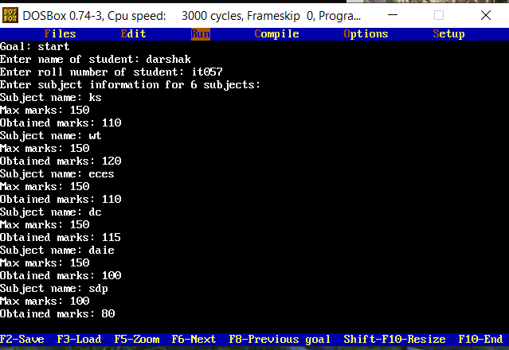

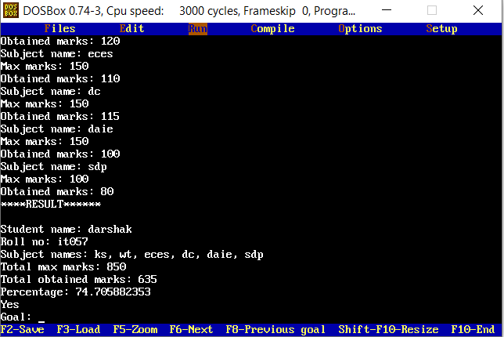

**domains**

**predicates**

**start**

**clauses**

**start:-**

**write("Enter name of student: "), readln(N),**

**write("Enter roll number of student: "), readln(R),**

**write("Enter subject information for 6 subjects: \n"),**

**write("Subject name: "), readln(S1),**

**write("Max marks: "), readint(T1),**

**write("Obtained marks: "), readint(M1),**

**write("Subject name: "), readln(S2),**

**write("Max marks: "), readint(T2),**

**write("Obtained marks: "),readint(M2),**

**write("Subject name: "), readln(S3),**

**write("Max marks: "), readint(T3),**

**write("Obtained marks: "), readint(M3),**

**write("Subject name: "), readln(S4),**

**write("Max marks: "), readint(T4),**

**write("Obtained marks: "), readint(M4),**

**write("Subject name: "), readln(S5),**

**write("Max marks: "), readint(T5),**

**write("Obtained marks: "), readint(M5),**

**write("Subject name: "), readln(S6),**

**write("Max marks: "), readint(T6),**

**write("Obtained marks: "), readint(M6),**

**write("****RESULT****** \n\n"),**

**write("Student name: "), write(N), nl,**

**write("Roll no: "), write(R), nl,**

**write("Subject names: ",S1,", ",S2,", ",S3,", ",S4,", ",S5,", ",S6), nl,**

**T=T1+T2+T3+T4+T5+T6,**

**M=M1+M2+M3+M4+M5+M6,**

**write("Total max marks: "), write(T), nl,**

**write("Total obtained marks: "), write(M), nl,**

**write("Percentage: "),**

**P=(M/T)*100,**

**write(P),nl.**

* Accept department, designation, name, age, basic salary, house rent allowance(HRA) of an employee . Compute dearness allowance (DA) which is 15% of basic salary . Determine the gross salary(basic salary+HRA+DA) of the employee. Display all information of the employee. (Use variables, rules, I/O predicates, arithmetic operators as per needed).

**Code:**

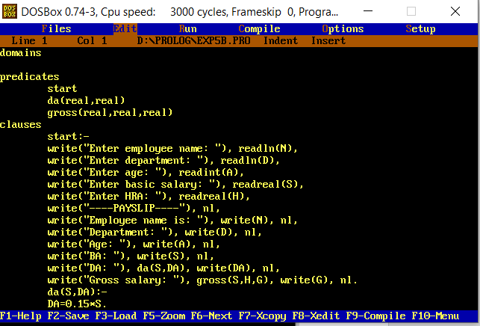

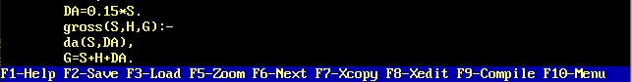

**Output:**

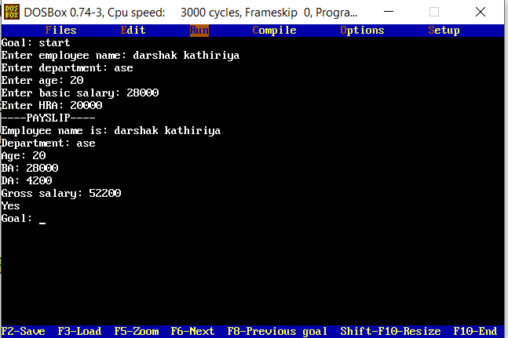

domains

predicates

start

da(real,real)

gross(real,real,real)

clauses

start:-

write("Enter employee name: "), readln(N),

write("Enter department: "), readln(D),

write("Enter age: "), readint(A),

write("Enter basic salary: "), readreal(S),

write("Enter HRA: "), readreal(H),

write("----PAYSLIP----"), nl,

write("Employee name is: "), write(N), nl,

write("Department: "), write(D), nl,

write("Age: "), write(A), nl,

write("BA: "), write(S), nl,

write("DA: "), da(S,DA), write(DA), nl,

write("Gross salary: "), gross(S,H,G), write(G), nl.

da(S,DA):-

DA=0.15*S.

gross(S,H,G):-

da(S,DA),

G=S+H+DA.